

**TR Consolidated NetApp Build Standards**

**Standards for Configuration and Build of NetApp Systems**

**Synopsis:** This document details the standards to be used when commissining or upgrading a new NetApp in a TR Data Center..

**Segment:** Data Centre Engineering and Managed Services – Storage

**Authors: Ian Daniel, Craig Goettig**

**Contributors: Santhana Ramasamy**

**Document Version:** V 0.18

**Date:** 8th Nov 2016

Document Status: Released

**CONFIDENTIAL INFORMATION**

This document contains information proprietary to Thomson Reuters and may not be reproduced, disclosed or used in whole or part without express permission of Thomson Reuters.

© Thomson Reuters 2016

Contents

1 Introduction 4

1.1 Management Summary 4

1.2 Document Scope 4

1.3 References 4

1.4 Change History 4

1.5 Distribution List 4

1.6 Glossary 5

2 Data Centres 6

3 Performance Guidelines 6

4 NetApp Controller and Storage Configurations 7

4.1 FAS2240 – Shared Primary 7

4.2 FAS2240 – Backup 7

4.3 FAS3220 – Shared Primary 7

4.4 FAS3220 – Backup 8

4.5 FAS3250 – Shared Primary 8

4.6 FAS3250 – Backup 8

4.7 FAS6210 - Tier 1 9

4.8 FAS6210 Tier 2 9

4.9 FAS6210 Backup 10

4.10 DS2246 Disk Shelves 10

4.11 DS4243 Disk Shelves 11

4.12 DS4486 Disk Shelves (Only for Dedicated MTS BU) 11

5 Aggregate Configurations 12

5 Volume, Qtree and LUN Configurations 12

5.1 Volume Guidelines 12

5.1.1 Thin Provisioning Rules 12

5.1.2 Volume Sizes 13

5.2 Qtree Guidelines 13

5.3 LUN Guidelines 14

5.4 Export Guidelines 14

6 Network Configuration 15

6.1 LACP – Interface Groups 15

6.2 MTU 15

6.2.1 Flowcontrol 15

6.3 Legacy – Interface Groups 15

6.4 Physical Management Connectivity 17

6.5 IP Spaces and VLANs 17

6.6 Management Protocols 18

6.7 Firewalls 18

7 Monitoring 19

7.1 System Alerting 19

7.2 Performance Monitoring 19

7.2.1 Default Performance Monitoring Rules 19

7.3 Operations Manager Servers (Markets) 19

7.4 Operations Manager Servers (Professional) 20

8 Backups 20

8.1 WISP/WIP 20

8.1.1 WISP/WIP Dependencies : 20

8.2 SnapVault Stacking 21

8.2.1 SnapVault Stacking Rules 21

8.2.2 SnapVault Backup Volume Sizes 22

9 Options Settings 22

9.1 Cluster Options 22

9.2 NFS v4 Options (Standard ONLY for MQ Deployments) 23

9.3 Additional Cluster Settings - For use in Markets only 23

9.4 Additional Cluster Settings - For use in Professional only 24

9.5 NFS v3 Options 24

9.6 CIFS Options 24

9.4 ISCSI Options 24

**Table of figures**

Figure 1 - FAS2240-2 Rear 6

Figure 2 - FAS2240-4 Rear (Backup) 6

Figure 3 - FAS3220 Rear 6

Figure 4 - FAS3220 Rear (Backup) 7

Figure 5 - FAS3250 Rear 7

Figure 6 - FAS3250 Rear (Backup) 7

Figure 7 - FAS6210 Rear (Tier 1) 8

Figure 8 - FAS6210 Rear (Tier 2) 8

Figure 9 - FAS6210 Rear (Backup) 9

Figure 10 - DS2246 Front 9

Figure 11 - DS2246 Rear 9

Figure 12 - DS4243 Front 10

Figure 13 - DS4243 Rear 10

Figure 14 - DS4486 Front 10

Figure 15 - DS4486 Rear 10

# Introduction

## Management Summary

This document details the configuration and options to be used when commissioning or upgrading a NetApp within a TR Data Center. It will provide standards for aggregates, networks, system configurations, connectivity, management and option settings.

## Document Scope

An amount of NetApp knowledge is assumed and also knowledge of the TR Data Centers.

## References

|  |  |  |  |  |
| --- | --- | --- | --- | --- |
|  | **Document** | **Version** | **Date** | **Author** |
| 1 | [Standard Architectures](https://theshare.thomsonreuters.com/sites/AI/storwiki/Shared%20Documents/Forms/AllItems.aspx?RootFolder=%2fsites%2fAI%2fstorwiki%2fShared%20Documents%2fNetApp_Std_Preso_2012&FolderCTID=0x012000323042D529A29948A4BD97896E56B34E) | 2012 | N/A | Architecture Group |
| 2 | [NFS v4 WI](https://theshare.thomsonreuters.com/sites/DCO_Storage/_layouts/WordViewer.aspx?id=/sites/DCO_Storage/Unified%20Storage%20DE%20Documents/NETAPP/Ontap%207-Mode%20STANDARDS/NFSv4%207%20Mode.docx&Source=https%3A%2F%2Ftheshare%2Ethomsonreuters%2Ecom%2Fsites%2FDCO%5FStorage%2FUnified%2520Storage%2520DE%2520Documents%2FForms%2FAllItems%2Easpx%3FRootFolder%3D%252Fsites%252FDCO%255FStorage%252FUnified%2520Storage%2520DE%2520Documents%252FNETAPP%252FOntap%25207%252DMode%2520STANDARDS%26FolderCTID%3D0x012000AB5215BBC1BB19479CB110210D2FC4B7&DefaultItemOpen=1&DefaultItemOpen=1) | 2016 | N/A | Unified Storage Engineering |

## Change History

|  |  |  |  |
| --- | --- | --- | --- |
| **Ver** | **Date** | **Author** | **Key Changes** |
| 0.1 | 08-Feb-2013 | Ian Daniel | Initial version |
| 0.2 | 12-Feb-2013 | Santhana Ramasamy | Updated defaults and provided information for options, LUN and ISCSI settings. |
| 0.3 | 13-Feb-2013 | Ian Daniel | Updated TZ information and some volume capacities. Updated NFS transfer size option. |
| 0.4  0.5  0.6 | 14-Feb-2013  20-Feb-2013  20-Feb-2013 | Santhana Ramasamy  Santhana Ramasamy  Santhana Ramasamy | Updated VI volume size and snap schedules. New standard moving forwards in line with exProf and using SnapVault.  Added shelf DS4486  Updated WISP standalone and cluster DB details |
| 0.7 | 21-02-2013 | Ian Daniel | Updated some formatting |
| 0.8 | 21-Feb-2013 | Ian Daniel | Added shelf diagrams and table of figures. |
| 0.9  0.10 | 22-Feb-2013  28-Feb-2013 | Ian Daniel  Santhana Ramasamy | Added performance guidelines  Updated WISP, flowcontrol details |
| 0.11 | 01-Mar-2013 | Ian Daniel | Updated aggregate table with new values for 2240 Backup. |
| 0.12 | 07-Mar-2013 | Ian Daniel | Updated with OPS Manager details for Markets and some details for Professional. |
| 0.13 | 08-Mar-2013 | Ian Daniel | Modified OPS Manager Details. |
| 0.14 | 08-Jun-2015 | David Ng | Updated aggr over commit |
| 0.15 | 26-Jun-2015 | Craig Goettig | Added SnapVault stacking rules |
| 0.16 | 28-July-2015 | Craig Goettig | Added SnapVault stacking backup volume sizes. |
| 0.17 | 23-Feb-2016 | Ian Daniel | Added NFS v4 |
| 0.18 | 08-Nov-2016 | Adrian Wicks | Added 5.4, Export Guidelines |

## Distribution List

|  |  |
| --- | --- |
| **Name** | **Role** |
| DCO-CIS-STO-DE-ALL | Storage Design and Engineering team |

## Glossary

|  |  |
| --- | --- |
| **Term** | **Definition** |
|  |  |

# Data Centres

The following table shows the Data Centres into which NetApp controllers will be deployed. The status of the Data Centre is also shown.

|  |  |  |
| --- | --- | --- |
| **Data Centre** | **Status** | **Abbreviation** |
| Eagan | Strategic | EG |
| Hazlewood | Strategic | HZ |
| Austen | Strategic | AU |
| Singapore | Strategic | SG |
| UK1 | Strategic | ?? |
| DTC | Strategic | LN |
|  |  |  |
| HK | Non-Strategic | HK |
| Hartland | Non-Strategic | ?? |
| UK2 | Non-Strategic | ?? |
| Nutley | Non-Strategic | ?? |
| Piscataway | Non-Strategic | ?? |
|  |  |  |
|  |  |  |

# Performance Guidelines

The following table shows the peak performance capabilities of each TR NetApp storage solution.

|  |  |  |
| --- | --- | --- |
| **Controller Configuration** | **Peak Throughput at 32K 50/50 Read/Write mix** | **Peak IOPS at 4K 50/50 Read/Write mix** |
| FAS2240 Shared Primary | 334MB/Sec per Controller  10714 IOPS per Controller | 11574 IOPS per Controller  45MB/Sec per Controller |
| FAS2240 Backup | Backup Filer N/A | Backup Filer N/A |
| FAS3220 Shared Primary | 443MB/Sec per Controller  14204 IOPS per Controller | 17123 IOPS per Controller  66MB/Sec per Controller |
| FAS3220 Backup | Backup Filer N/A | Backup Filer N/A |
| FAS3250 Shared Primary | 496MB/Sec per Controller  15873 IOPS per Controller | 24294 IOPS per Controller  94MB/Sec per Controller |
| FAS3250 Backup | Backup Filer N/A | Backup Filer N/A |
| FAS6210 Tier 1 | 850MB/Sec per Controller  27200 IOPS per Controller | 57000 IOPS per Controller  222MB/Sec per Controller |
| FAS6210 Tier 2 | 637MB/Sec per Controller  20400 IOPS per Controller | 47250 IOPS per Controller  166MB/Sec per Controller |
| FAS6210 Backup | Backup Filer N/A | Backup Filer N/A |

# NetApp Controller and Storage Configurations

We have a number of standard configurations that can be deployed into a TR data centre. These are as follows:

## FAS2240 – Shared Primary

The standard configuration is as follows.

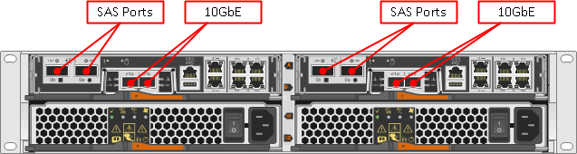

Figure 1 - FAS2240-2 Rear

## FAS2240 – Backup

The standard configuration is as follows.

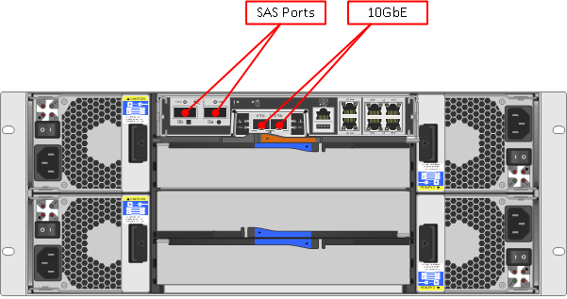

Figure 2 - FAS2240-4 Rear (Backup)

## FAS3220 – Shared Primary

The standard configuration is as follows.

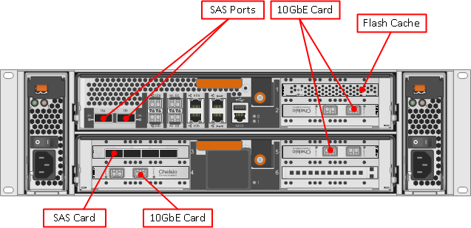

Figure 3 - FAS3220 Rear

## FAS3220 – Backup

The standard configuration is as follows.

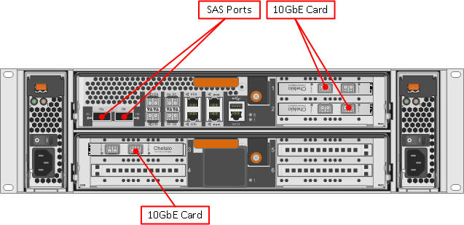

Figure 4 - FAS3220 Rear (Backup)

## FAS3250 – Shared Primary

The standard configuration is as follows.

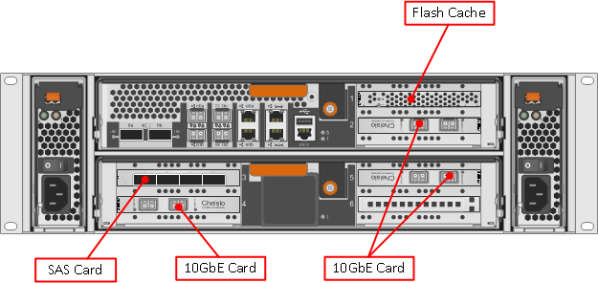

Figure 5 - FAS3250 Rear

## FAS3250 – Backup

The standard configuration is as follows.

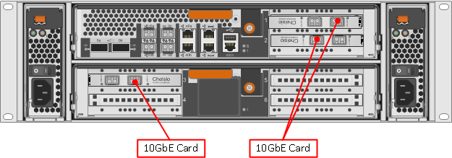

Figure 6 - FAS3250 Rear (Backup)

## FAS6210 - Tier 1

The standard configuration is as follows.

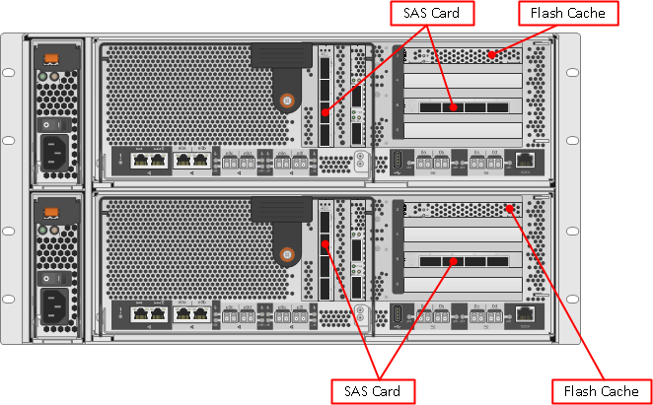

Figure 7 - FAS6210 Rear (Tier 1)

## FAS6210 Tier 2

These systems are deployed as part of a standard FAS6210 High/Low tier arrangement. The standard configuration is as follows.



Figure 8 - FAS6210 Rear (Tier 2)

## FAS6210 Backup

These systems are deployed as part of a standard FAS6210 High/Low tier arrangement as a backup device The standard non-HA configuration is as follows.

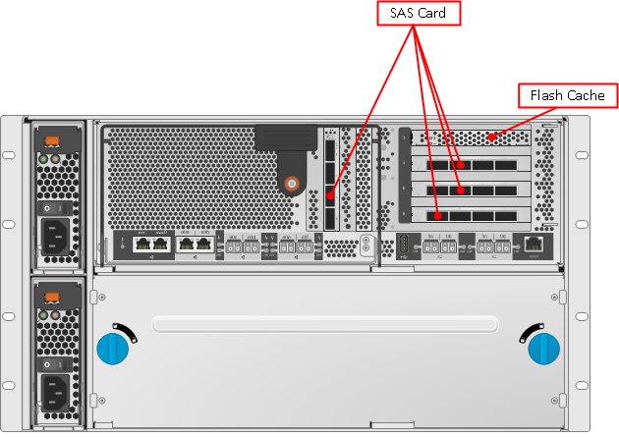

Figure 9 - FAS6210 Rear (Backup)

## DS2246 Disk Shelves

These shelves are the standard offering for storage attached to the smaller NetApp controllers in TR. Supported disk types are: 600GB SAS and 2TB SATA.

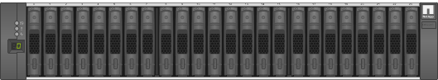

Figure 10 - DS2246 Front

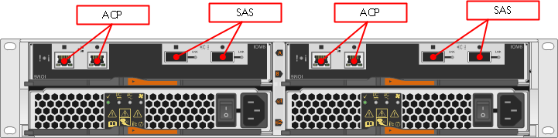

Figure 11 - DS2246 Rear

## 

## DS4243 Disk Shelves

These shelves are the standard offering for storage attached to NetApp controllers in TR. Supported disk types are: 450GB SAS and 2TB SATA.

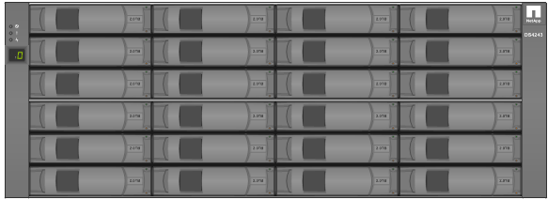

Figure 12 - DS4243 Front

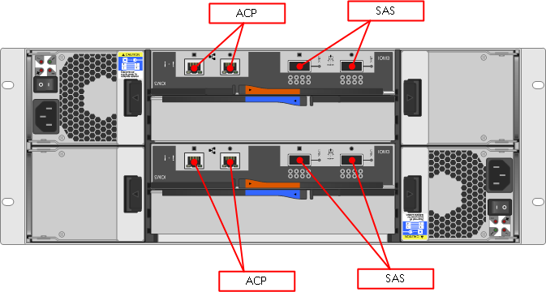

Figure 13 - DS4243 Rear

## DS4486 Disk Shelves (Only for Dedicated MTS BU)

These shelves are not currently the standard offerings. As of now this is been used only in Litigation MTS BU as an exception.

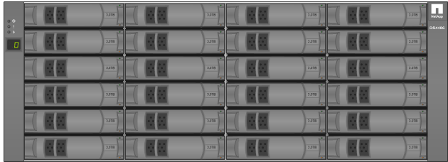

Figure 14 - DS4486 Front

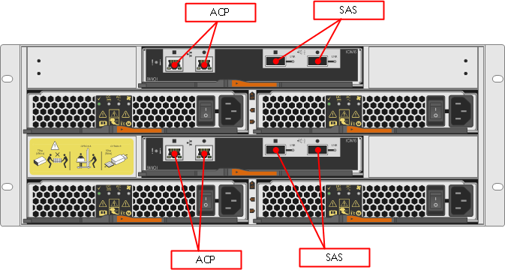

Figure 15 - DS4486 Rear

# Aggregate Configurations

Aggregate configurations differ per device and disk type, the following table details the current configurations are shown below:

|  |  |  |  |  |  |  |  |  |  |  |  |
| --- | --- | --- | --- | --- | --- | --- | --- | --- | --- | --- | --- |
| **DOT** | **Tier** | **Model** | **Disk Size** | **RG Config** | **RG Usable (TB)** | **Max RG/Aggr** | **Max Aggr/Ctlr** | **Aggr Size Max Usable (TB)** | **Spares** | **% Usable Threshold** | **Notes** |
| 8.1.x | 1 | FAS2240 | 600 | 15 | 6.39 | 3 | 1 | 19.1 | 3 | 75 | DS2246 Shelves  (10K Drives) |
|  | BKP | FAS2240 | 2000 | 15 | 19.37 | 2 + 13 Drives | 1 | 52.37 | 5 | 75 | DS4243 Shelves |
|  | 1 | FAS3220 | 600 | 15 | 6.39 | 3 | 1 | 19.1 | 3 | 75 | DS2246 Shelves  (10K Drives) |
|  | BKP | FAS3220 | 2000 | 15 | 19.37 | 3 | 1 | 58.11 | 3 | 75 | DS4243 Shelves |
|  | 1 | FAS3250 | 600 | 15 | 6.39 | 3 | 1 | 19.1 | 3 | 75 | DS2246 Shelves  (10K Drives) |
|  | BKP | FAS3250 | 2000 | 15 | 19.37 | 3 | 1 | 58.11 | 3 | 75 | DS4243 Shelves |
|  | 1 | FAS6210 | 450 | 20 | 6.61 | 7 | 1 | 46.28 | 4 | 75 | DS4243 Shelves |
|  | 2 | FAS6210 | 2000 | 15 | 19.37 | 4 + 9 Drives | 1 | 87.91 | 3 | 75 | DS4243 Shelves |
|  | BKP | FAS6210 | 2000 | 15 | 19.37 | 7 | 3 | 135.6 | 15 | 75 | DS4243 Shelves |

The aggregate sizes and layouts above are based on the TR Architecture Groups specifications.

# Volume, Qtree and LUN Configurations

## Volume Guidelines

The following lists standard volume sizes and configurations that should be used as a basis when deploying storage for customers. All volumes are to be thin provisioned.

### Thin Provisioning Rules

|  |  |
| --- | --- |
| **Component** | **Required Value** |
| Aggregate Physical Utilisation | 75% |
| Maximum Aggregate Overcommit | 200% for all filers except 6080 which remain at 120% |
| Data Volume Snap Reserve | 20% |
| Page File/Swap Volume Snap Reserve | 0% |
| Volume Autosize Maximum | N/A |
| Volume Growth Increment | N/A |
| try_first | snap_delete (Primary volumes) |
| try_first | volume_grow (Secondary volumes) |
| volume guarantee | None |
| vol autosize | Off |
| **Snapshot Management** |  |
| snap autodelete | On |
| snap autodelete trigger | reserve |
| snap autodelete delete_order | oldest_first |
| snap autodelete commitment | Try |
| snap autodelete target_free_space | 20% |
| **Deduplication** |  |
| Deduplication Enabled On Datastore | Yes |
| Deduplication Enabled On Swap Datastore | No |
| Deduplication Enabled On Pagefile Datastore | No |
| Deduplication Enabled On Application Datastore | Yes |
| DB Storage | **Disabled for DB storage** |
| Deduplication Enabled On NFS/CIFS Volume | Enabled for file shares and datastores |

### Volume Sizes

|  |  |  |  |  |  |  |
| --- | --- | --- | --- | --- | --- | --- |
| **Volume Type** | **Size** | **Snap Reserve (%)** | **Snap Schedule** | **Snap AutoDelete** | **Auto Size** | **SnapVault**  **Backup** |
| VI Data | 3400 | 20 | 7@sun-sat@2 with only SnapVault(schedule timing depends on location)  0 30 0  With Tape (Markets Legacy ONLY) | Trigger on reserve | No | Yes |
| VI Page | 1024 | 0 | N/A | N/A | No | No |
| VI Swap | 1024 | 0 | N/A | N/A | Yes | No |
| CIFS/NFS Share | Dependent on requirement and specified when requested | 20 | Dependent on requirement and specified when requested. | Trigger on reserve | No | Yes |
| LION Share | Dependent on requirement and specified when requested | 20 | Dependent on requirement and specified when requested | Trigger on reserve | No | Yes |
| WISP Share | Dependent on requirement and specified when requested | 20 | Dependent on requirement and specified when requested | Trigger on reserve | No | Yes |

## Qtree Guidelines

Qtrees should be used when creating shares and will follow the naming standards.

**Note**: All qtrees must have quotas and if this is not specified during the build it will be ignored.

## LUN Guidelines

LUNs are used for ISCSI deployments, mainly in WISP. All LUNs are to be thin provisioned and are to follow these guidelines.

|  |  |
| --- | --- |
| **Details** | **Primary Configuration** |
| SQL Server Volume/LUN limits | 6TB |
| Lun limitation ( number) | 20 LUNS per system & 40 LUNS per cluster |
| **Multiple databases per volume** | <= 315 DB's per server |
|  | 35 DB's per volume |
|  | <= 200GB per database |
| **Single database per volume** | >200GB per database |
|  | 6TB volume limit |
| **Multiple databases per volume** | >315 DB's per server (Max DB's 1200) |
|  | 150 DB's per volume |
|  | Average user database size <=10GB |
|  | Maximum user database size <=50GB |
| **WISP V3** | Multiple databases per volume >315 DB's per server (Max DB's 1950) |
|  | 150 DB's per volume |
|  | Average user database size <=10GB |
|  | Maximum user database size <=50GB |
| **WISP STANDARD CONFIG FOR STANDALONE DB SERVER** | SNAP VOL1  **E:\ 50GB** --> data drive  **G:\ 25GB** --> log drive |
|  | SNAP VOL2   **S:\ 10GB** --> snapinfo drive |
|  | NOSNAP VOL1    **H:\ 25GB** --> sysdb lun |
| **WISP CLUSTERED DB** | SNAP VOL1  **E:\ 50GB  G:\ 25GB** |
|  | SNAP VOL2  **S:\ 10GB** |
|  | NOSNAP VOL1   **H:\ 25GB**  **Q:\ 1GB** --> Quorum lun |

## Export Guidelines

Hosts should now be granted the required access at the volume level and permissions will be inherited down to the qtrees.

# Network Configuration

## LACP – Interface Groups

The standard network configuration in the TR environment is a LACP interface group where networks will support it.

Network Configurations are as follows for supported NetApp controllers.

|  |  |  |
| --- | --- | --- |
| **Controller Type** | **Primary Configuration** | **Expansion Configuration** |
| FAS2240 – Shared Storage | e1a + e1b | N/A |
| FAS2240 – Backup | e1a + e1b | N/A |
| FAS3220 – Shared Storage | e2a + e5b | e5a + e6b and e6a + e2b |
| FAS3220 – Backup | e1a + e2b | e2a + e3b and e3a + e1b |
| FAS3250 – Shared Storage | e2a + e5b | e5a + e6b and e6a + e2b |
| FAS3250 – Backup | e1a + e2b | e2a + e3b and e3a + e1b |
| FAS6210 – Tier 1 | e0c + e0e | e0d + e0f |
| FAS6210 – Tier 2 | e0c + e0e | e0d + e0f |
| FAS6210 - Backup | e0c + e0e | e0d + e0f |

## MTU

For all deployments the LACP 10GbE interfaces should be set with an MTU of 9000

Legacy Markets environments will normally use an MTU of 9000 for VI deployments but may have a 1500 MTU set on CIFS shares or NFS shares**.**

The default going forwards is 9000

### Flowcontrol

Flowcontrol will be disabled (None) by default for all the interfaces. Example,

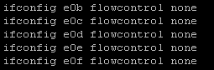

## Legacy – Interface Groups

The legacy network configuration in the TR environment (Storage Backplane) is a single mode (active/passive) interface group. This is only to be used when attaching to switches that do not support LACP.

Generally this will be an additional configuration requiring the use of expansion ports or expansion cards and not the default connection method.

For FAS6210 Deployments attachments can be made using additional 10GbE cards. For 32xx series controllers with a standard configuration some of the spare ports can be used. The FAS22xx controllers will normally not be connected to a storage backplane.

There will need to be 2 sets of single mode ifgrps for a storage backplane configuration. One for the Core cell and the other for the Service cell.

## Physical Management Connectivity

The additional configuration required for management connectivity is as follows.

|  |  |  |
| --- | --- | --- |
| **Controller Type** | **Management** | **ACP** |
| FAS2240 – Shared Storage | e0a – 1 x GbE Port  Wrench port – RLM/SP  Serial Console – **Only if no RLM connectivity.** | Locked wrench port |
| FAS2240 – Backup | e0a – 1 x GbE Port  Wrench port – RLM/SP  Serial Console – **Only if no RLM connectivity.** | Locked wrench port |
| FAS3220 – Shared Storage | e0a – 1 x GbE Port  Wrench port – RLM/SP  Serial Console – **Only if no RLM connectivity.** | Locked wrench port |
| FAS3220 – Backup | e0a – 1 x GbE Port  Wrench port – RLM/SP  Serial Console – **Only if no RLM connectivity.** | Locked wrench port |
| FAS3250 – Shared Storage | e0a – 1 x GbE Port  Wrench port – RLM/SP  Serial Console – **Only if no RLM connectivity.** | Locked wrench port |
| FAS3250 – Backup | e0a – 1 x GbE Port  Wrench port – RLM/SP  Serial Console – **Only if no RLM connectivity.** | Locked wrench port |
| FAS6210 – Tier 1 | e0a – 1 x GbE Port  Wrench port – RLM/SP  Serial Console – **Only if no RLM connectivity.** | Locked wrench port |
| FAS6210 – Tier 2 | e0a – 1 x GbE Port  Wrench port – RLM/SP  Serial Console – **Only if no RLM connectivity.** | Locked wrench port |
| FAS6210 - Backup | e0a – 1 x GbE Port  Wrench port – RLM/SP  Serial Console – **Only if no RLM connectivity.** | Locked wrench port |

## IP Spaces and VLANs

IP Spaces and VLANs are used to segregate traffic between vfilers. The standard configuration uses three VLANs and all are resident in the same IP Space (default).

In legacy environments we have a different configuration where there is a separate VLAN and IP Space for each vfiler. This configuration needs to still be used when attaching to a storage backplane network.

**Note:** In TR the default vfiler (vfiler0) VLAN and IP Space should always be used to perform the data copy/migration. In legacy markets environments the same applies with regard to the base vfiler (vfiler0) but VLAN IDs 199 and 200 are used by default in most locations.

## Management Protocols

All management protocols should be secure wherever possible. Use of SSH and HTTPS are mandatory.

## Firewalls

For standard non-Legacy deployments firewalls should not need consideration.

Firewalls are in use throughout the legacy environments and the following table shows ports that will need to be opened to ensure management connectivity to the NetApp controllers.

|  |  |  |  |  |  |
| --- | --- | --- | --- | --- | --- |
| Number | Description | Source | Destination | Initiator (Source, Destination, Both) | Port/Protocol |
| 1 | Communication between Operations Manager Server and NetApp array | NetApp Array | Operations Manager Servers | Both | UDP/161  UDP/162  TCP/80  TCP/443  TCP/8443  TCP/8080  TCP/10000 |
| 2 | Communication between Operations Manager Server and NetApp array | Operations Manager Server | NetApp Array | Both | TCP/22  ICMP |
| 3 | NetApp Management Console communication to Operations Manager Database | Operations Manager Server | NetApp Management & NMC Workstation or Operations Manager Web Interface | Both | TCP/8443  TCP/8080  TCP/8088  TCP/8488  RDP/5616 |
| 4 | GMI Alerting | Operations Manager Server and WFA Server | GMI Netcool | Source | Standard GMI management ports  UDP/161  UDP/162 |
| 5 | TSM Backup Traffic | Operations Manager Server | TSM | Destination | Standard TSM ports  1500, 1505, 1510, 1520, 1530, 1540, 1550  1509, 1519, 1529, 1539, 1549, 1559 |
| 6 | SMTP for Management reporting | Operations Manager Server and WFA Server | Aurora SMTP gateway | Source | SMTP outbound  TCP/25 |
| 7 | Caching OPS Manager | WFA Server | OPS Manager Server | Destination | TCP/2638 |
| 8 | Command execution (ZAPI, PowerCLI) | WFA Server | NetApp Array | Source | TCP/22, 80, 443 |
| 9 | Desktop Access | NetApp Management & NMC Workstation or Operations Manager Web Interface | WFA Server | Destination | TCP/80, 443 |
| 10 | Caching VC | WFA Server | VC | Source | TCP/1433 |

# Monitoring

## System Alerting

For all new deployments management is performed via OnCommand servers running on Linux. Alerts are sent to trap hosts which facilitate the automated logging of tickets.

Most of the DFM alerts are been converted in to EMAT alert which will generate the tickets in various priority depends on the alert.

This is all depends on the EMAT configuration. All basic issues like disk, shelf, snapshot are initially dealt with by the DCO L1 team.

## Performance Monitoring

For all new deployments performance monitoring data is captured into NetApp Performance Advisor. There is a build script which is run to set this up**.**

DFM threshold alerts are set on all the DFM machines. This will send an email if any of the resources like latency, IOPs, network utilization goes beyond the thresholds.

### Default Performance Monitoring Rules

Read_latency <=20ms

Write_latency <=5ms

## Operations Manager Servers (Markets)

The following table lists the servers in use for alerting and performance monitoring along with the controllers they manage.

|  |  |
| --- | --- |
| **Site** | **Server Name(s)** |
| UK1 (CPS) | UK1P-OPSMG01A / UK1P-OPSMG01B |
| UK2 (CPS) | UK2P-OPSMG01A / UK2P-OPSMG01B |
| HAZELWOOD (CPS) | HDCP-OPSMG01A / HDCP-OPSMG01b |
| HARTLAND (CPS) | OCDP-OPSMG01A / OCDP-OPSMG01A |
| HARTLAND (CIS) | OCDS-OPSMG01A / OCDS-OPSMG01B |
| HONG KONG (CPS) | HK1P-OPSMG01A / HK1P-OPSMG01B |
| SINGAPORE (CPS) | SG1P-OPSMG01A / SG1P-OPSMG01B |

## Operations Manager Servers (Professional)

|  |  |
| --- | --- |
| **Site** | **Server Name(s)** |
| CIS | cmp111cwq.int.westgroup.com |
| CIS | cmp111dfm.int.westgroup.com |
| CIS | cmp111mgc.int.westgroup.com |
| CIS | c111ujr.int.westgroup.com |
| CIS | cmp111xjq.int.westgroup.com |
| CPS | nerstrand.int.westgroup.net |
| CPS | newnan.int.westgroup.net |
| CPS | nidaros.int.westgroup.net |

# Backups

For all new deployments SnapVault is the preferred backup mechanism and should be used without exception. The following details the required configuration for SnapVault volumes and schedules.

## WISP/WIP

WISP solutions whether backups or "no" backups of the data are required will follow the same iSCSI drive and volume layouts. Systems requiring "no" backups will not require the HNAS-CIFS archive log location, this is only a requirement for systems requiring backups.

1. Volume based – SnapDrive (Also required for SQL deployments
2. SQL based - SnapManager for SQL (disk layout is below)

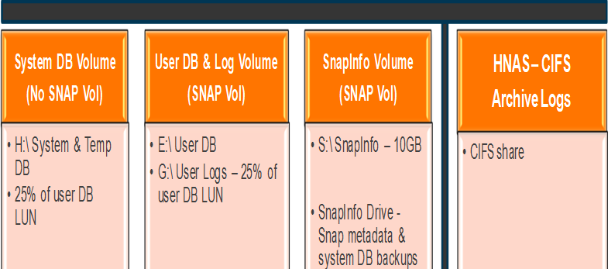

**Process:**

* WISP iscsi on Netapp NAS. For log backups, the SQL dbas run log backups out to a cifs share on HNAS. If that HNAS location cannot be written to, their log backups will be written to a Tier2 Netapp cifs share.

Example:

\\evs-ecomqc-002\dba_mssql

\\clnt-corp-f0317\dba_mssql

### WISP/WIP Dependencies :

1. **Required account:**

To make the snapdrive/snapvault work all vfiler must have below user account created

**a**. **iscsisv** – this user will be used to perform snapvault backup for the luns between source and target which will be maintained by automatic schedules.

1. **Trust relation** - Both vfiler and the client snapdrive uses ‘iscsi’ user should hold same password.Password can be pulled from windows team ( passwd generator)
2. **Snapvault :**

Snapvault default backup retension is based on the request from the client/business unit. By default DCO got 7,14,45 days retention , either one of the option can be used. Destination volume will reflect the volume name along with retension ( **eg:** sv_volumename_45)

**Schedules :** all the snapvault schedule starts @1,2,3 and need to distribute this to avoid overloading the filer at same time.

**Note:** Volumes with name “no_snap” will not be part of the backup and will not hold any snapshot by default.

1. **Snapmirror (DR solution) :**

For all DR solution , snapmirror is the techonology which will be used and this will remain in sync with primary frequently depends on the SLA (lag). Most of the case the technology will be used in dedicated filers as per the request. Example , Scholarone, IP & Science, Tax etc..

## SnapVault Stacking

In 7-mode backup filers there is a hard limit of 500 volumes per head. Because of this limitation, we are implementing SnapVault stacking. SnapVault stacking is where we utilize qtrees on a single group volume to reduce the overall volume count as well as better utilized the available capacity on our backup filers.

### SnapVault Stacking Rules

1. Stacking oraadm volumes
   1. Stack oraadm volumes with like retention
      1. 15 qtrees MAX for 7 and 14 day retention
      2. 5 qtrees MAX for 45 day retention
      3. Example group volume name: sv_07_cis_oraadm_grp01
2. Stacking VM volumes
   1. Stack VM volumes with like retention
      1. 15 qtrees MAX for 7 and 14 day retention
      2. 5 qtrees MAX for 45 day retention
      3. Example group volume name: sv_45_cis_virtual_grp01
3. Stacking oradata volumes
   1. Stack oradata volumes with like retention
      1. 5 qtrees MAX for 7, 14, and 45 day retention
      2. Example group volume name: sv_14_cps_oradata_grp01
4. Stacking flat file volumes
   1. Stack flat file volumes with like retention
      1. 15 qtrees MAX for 7 and 14 day retention
      2. 5 qtrees MAX for 45 day retention
      3. Example group volume name: sv_07_cis_grp01

### SnapVault Backup Volume Sizes

1. Oraadmin

Vol Size: 460800 MB

Autosize grow: 51200 MB

Max Size: 14680064 MB

1. Oradata

Vol Size: 41943040 MB

Autosize grow: 512000 MB

Max Size: 52428800 MB

1. Virtual

Vol Size: 41943040 MB

Autosize grow: 512000 MB

Max Size: 52428800 MB

1. Flat Files

Vol Size: 2097152 MB

Autosize grow: 512000 MB

Max Size: 15759375 MB

# Options Settings

For all new deployments the following options should be used for each vfiler when deploying it for a given protocol or protocols.

## Cluster Options

|  |  |
| --- | --- |
| **Option** | **Value** |
| httpd.admin.ssl.enable | on |
| ssh1.enable | off |
| ssh2.enable | on |
| telnet.distinct.enable | on |
| sftp.enable | on |
| telnet.enable | off |
| rsh.enable | off |
| httpd.enable | off |
| webdav.enable | off |
| httpd.admin.enable | on |
| httpd.admin.hostsequiv.enable | off |
| ftpd.enable | off |
| pcnfs.enable | off |
| snmp.enable | off |
| tftpd.enable | off |
| nis.enable | off |
| security.passwd.rules.enable | on |
| security.passwd.rules.enable | on |
| security.passwd.rules.everyone | on |
| security.passwd.lockout.numtries | 6 |
| security.passwd.rules.history | 6 |
| security.passwd.rules.maximum | 14 |
| security.passwd.rules.minimum | 8 |
| security.passwd.rules.minimum.alphabetic | 6 |
| security.passwd.rules.minimum.digit | 1 |
| security.passwd.rules.minimum.symbol | 1 |
| autologout.console.enable | on |
| autologout.console.timeout | 5 |
| ssh.idle.timeout | 300 |
| auditlog.enable | on |
| ip.match_any_ifaddr | off |
| ip.fastpath.enable | off |
| ip.ping_throttle.drop_level | 150 |
| ip.ping_throttle.alarm_interval | 5 |
| snapmirror.checkip.enable | on |
| ndmpd.authtype | Challenge |
| autosupport.enable | on |
| autosupport.nht_data.enable | off |
| autosupport.transansport | smtp |
| autosupport.mailhost | *Correct SMTP Server for data centre location* |
| autosupport.from | *hostname*@thomsonreuters.com |
| nfs.export.auto-update | off |
| nfs.tcp.recvwindowsize | 262144 |
| nfs.tcp.xfersize | 65536 |
| nfs.ifc.xmt.high | 64 |
| raid.scrub.duration | 120 |
| raid.scrub.enable | on |
| raid.scrub.schedule (**Markets only**) | **UK Data Centres (GMT)**  2h@mon@22,2h@tue@22,2h@wed@22,2h@thu@22 2h@fri@22  **US Data Centres (GMT – 6)**  2h@mon@04,2h@tue@04,2h@wed@04,2h@thu@04 2h@fri@04  **APAC Data Centres (GMT + 8)**  2h@mon@14,2h@tue@14,2h@wed@14,2h@thu@14 2h@fri@14  **Note:** All NetApp filers are set to GMT so we need to offset the schedules in non-UK data centres to account for this. |
| timed.proto | ntp |
| timed.enable | on |
| timed.servers | *Correct NTP Servers for data centre location* |

## NFS v4 Options (Standard ONLY for MQ Deployments)

|  |  |
| --- | --- |
| **Option** | **Value** |
| nfs.v4.enable | on |
| nfs.v4.id.domain | <your_domain_here> |

## Additional Cluster Settings - For use in Markets only

|  |  |
| --- | --- |
| **Setting** | **Value** |
| Timezone | GMT (Always GMT) |
| vol0 snapshot schedule | **UK Data Centres (GMT)**  0 30 0  **US Data Centres (GMT – 6)**  0 30@6 0  **APAC Data Centres (GMT + 8)**  0 30@16 0  **Note:** All NetApp filers are set to GMT so we need to offset the snapshot schedules in non-UK data centres to account for this. |

## Additional Cluster Settings - For use in Professional only

|  |  |
| --- | --- |
| **Setting** | **Value** |
| Timezone | Set to local Time Zone |

## NFS v3 Options

|  |  |
| --- | --- |
| **Option** | **Value** |
| nfs.tcp.recvwindowsize | 262144 |
| nfs.tcp.xfersize | 65536 |
| nfs.v3.enable | on |
| nfs.v4.enable | off |
| nfs.tcp.enable | On |

## CIFS Options

|  |  |
| --- | --- |
| **Option** | **Value** |
| cifs.max_mpx | 255 |
| cifs.neg_buf_size | 65340 |
| cifs.tcp_window_size | 262144 |
| cifs.smb2.enable | on |
| cifs.smb2.signing.required | off |
| cifs.oplocks.enable | on |
| cifs.smb2.durable_handle.enable | off |

## ISCSI Options

|  |  |
| --- | --- |
| **Option** | **Value** |
| iscsi.enable | On |
| iscsi.ip_based_tpgroup | Off |
| iscsi.max_ios_per_session | 128 |
| iscsi.tcp_window_size | 131400 |